**Kickstart My Chart**

**INTRODUCTION**

“Over $2 billion has been raised using the massively successful crowdfunding service, Kickstarter, but not every project has found success. Of the more than 300,000 projects launched on Kickstarter, only a third have made it through the funding process with a positive outcome.

Getting funded on Kickstarter requires meeting or exceeding the project's initial goal, so many organizations spend months looking through past projects in an attempt to discover some trick for finding success. For this week's homework, you will organize and analyze a database of 4,000 past projects in order to uncover any hidden trends.” (Trilogy Education Services ,2019)

**KEY FACTORS**

1. **Percent Funded:** How much money a campaign made to reach its initial goal.
2. **State:** Associated campaign was successful, failed, or canceled, or is currently live.
3. **Average Donation:** How much each backer for the project paid on average.
4. **Category:** The type of Kickstarter project theme
5. **Sub-category:** sub-type of the project Kickstarter theme
6. **Launched at:** Date Kickstarter project began
7. **Deadline:** Date Kickstarter project ended
8. **Number Successful:** The number of successful projects
9. **Success by Category:** The most successful projects by category
10. **Success by Date:** The start and end date of successful projects
11. **Number of Failed:** The number of projects failed
12. **Backer:** Individuals in support of the project
13. **Pledge:** Money donated in support of the project

**DATA EXPLORATION**

**Data Analysis**

Given the data provided we can make the following 3 conclusions:

1. Based on Figure 1, worldwide “Theater” Kickstarter projects were the most successful, followed by “Music” and “Technology.”

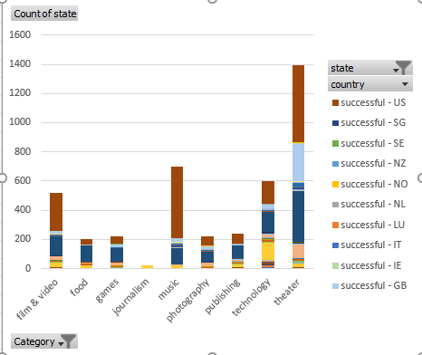

**Figure 1. Count of Successful Projects World Wide**

2. Based on Figure 2 we can also conclude that the number of backers although it does influence success rate does not determine if a project will succeed or fail. Although “Theater” was the most successful category, “Technology” had the most backers.

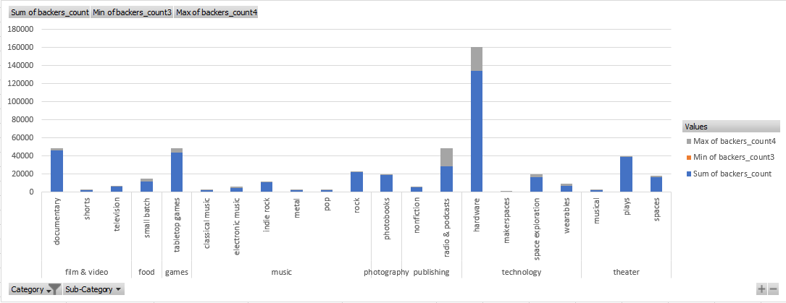

**Figure 2. Count of Backers per Category**

1. Based on Figure 3, we can conclude that although money influences the success rate it cannot be used as a determining factor of success. Although most cancelled Kickstarter projects did not raise their goal amount, the percent of those failed and the percent of successful projects is erratic.

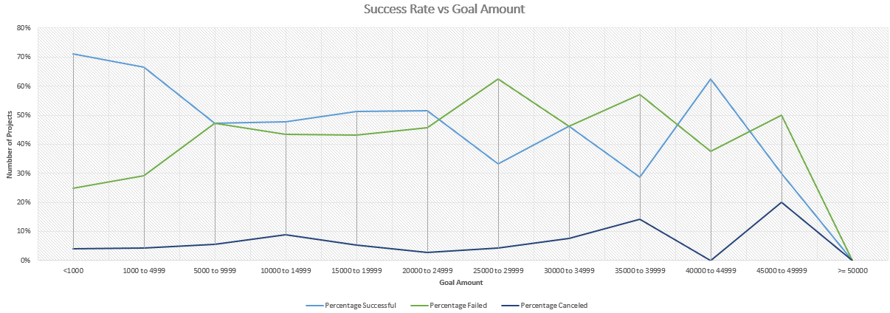

**Figure 3. Success rate based on Goal Amount**

**Limitations**

There are also several limitations to the data collected, although the data shows the origination of the Kickstarter project, there is no information on which part of the world the project did well or failed. Cultural preferences both domestic and international play a role in the success and failure of a project.

The data collected also does not show the type of marketing used for each kickstarter project or if any was used. Different age groups engage differently with different forms of advertisement. For example, millennials may be more influenced by social media versus a boomer who may prefer a television ad.

The data also does not show the entrepreneurs background (experience and training). Some entrepreneurs may have more experience and may have already had previous success with a Kickstarter project.

**Additional Data**

Additional information is needed to improve predictability of success and failure. We would need launch date and launch location to see what Kickstarter projects do better in which country.

We would also need background information on the entrepreneur to determine if experience is a factor in predicting the success or failure of a project.

Additional graphs we can make with the data we have is if the time of year the project is launched has a determining factor in success and failure of a project.

**Conclusion**

Unfortunately using statistical analysis of the count of backers did not provide much information other than having more backers is great source of collecting funds. The mean and median demonstrated that typically higher count equals improved chances of success. There seems to be more variability with successful projects versus non-successful projects, which does provide hope that predictability factors can be determined, at least to determine failure.

**References**

Trilogy Educational Services (2019) Excel Homework: Kickstart Mychart